**LAPORAN UTS**

**PEMROGRAMAN BERBASIS WEB**

*“Aplikasi Booking Cuci Mobil”*

Dosen Pengampu :

H. Bagja Nugraha, S.T., M.Kom



Disusun Oleh :

Ayutia Yasmin 2110631250032

Chandra Christian 2110631250035

Melati Nour Esa 2110631250049

Muhammad Aliffigo Y 2110631250051

**PROGRAM STUDI SISTEM INFORMASI**

**FAKULTAS ILMU KOMPUTER**

**UNIVERSITAS SINGAPERBANGSA KARAWANG**

**2023**

**DIAGRAM UML**

1. **Use Case Diagram**

1. **Activity Diagram**

1. **Sequence Diagram**

**STRUKTUR DATABASE**

1. **Tabel customer**

1. **Tabel jenis_cucian**

1. **Tabel pendaftaran**

1. **Tabel saran**

1. **Tabel transaksi**

1. **Tabel type_mobil**

1. **Tabel user**

**ERD BOOKING CUCI MOBIL**

**MOCKUP APLIKASI**

1. **Landing Page**

1. **Menu Pendaftaran Landing Page**

1. **Menu Kritik Dan Saran Landing Page**

1. **Menu Login**

1. **Dashboard Admin**

1. **Menu Pendaftaran**

1. **Menu Transaksi**

1. **Menu Customer**

1. **Menu Data Export Pendaftar**

1. **Menu Data Admin**

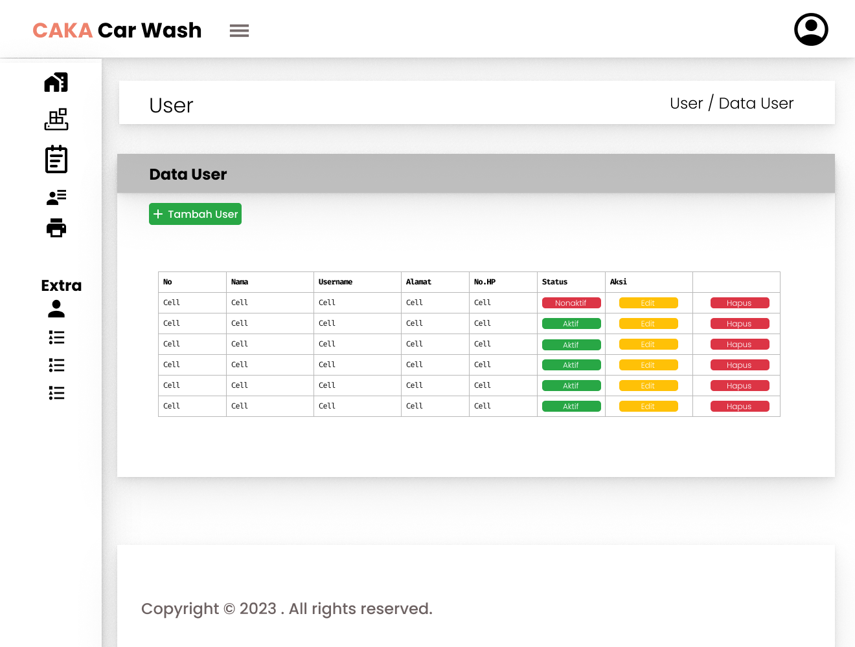

1. **Menu Type Mobil**

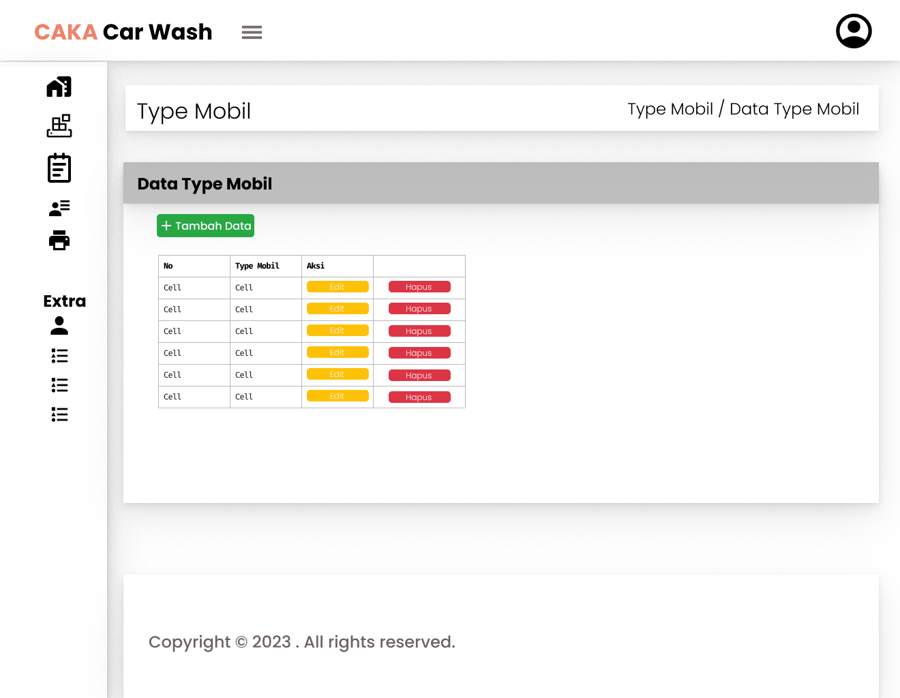

1. **Menu Jenis Cucian**

1. **Menu Kritik Dan Saran**

